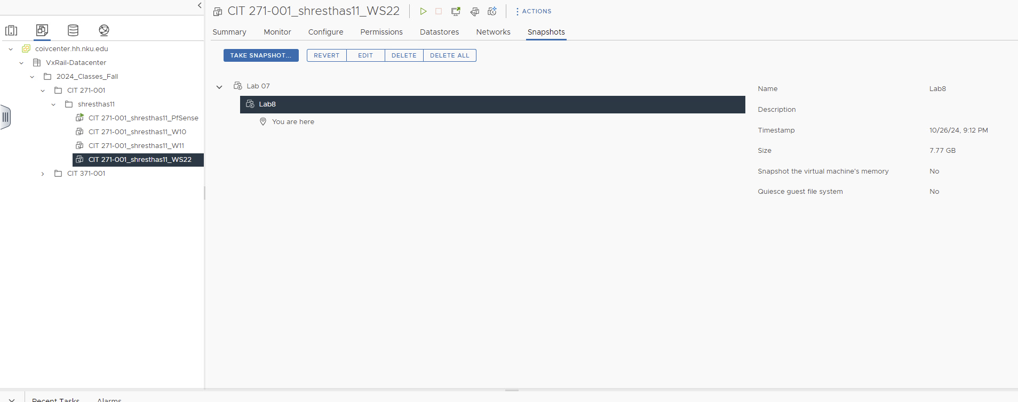
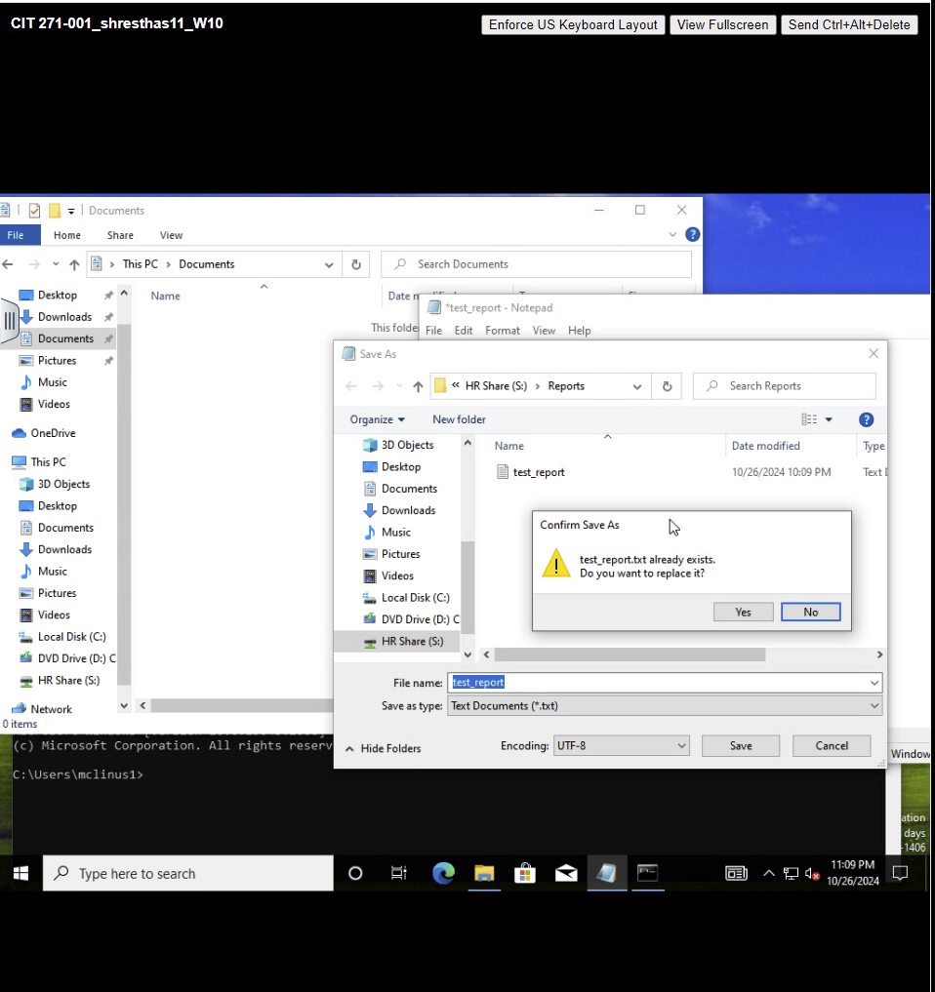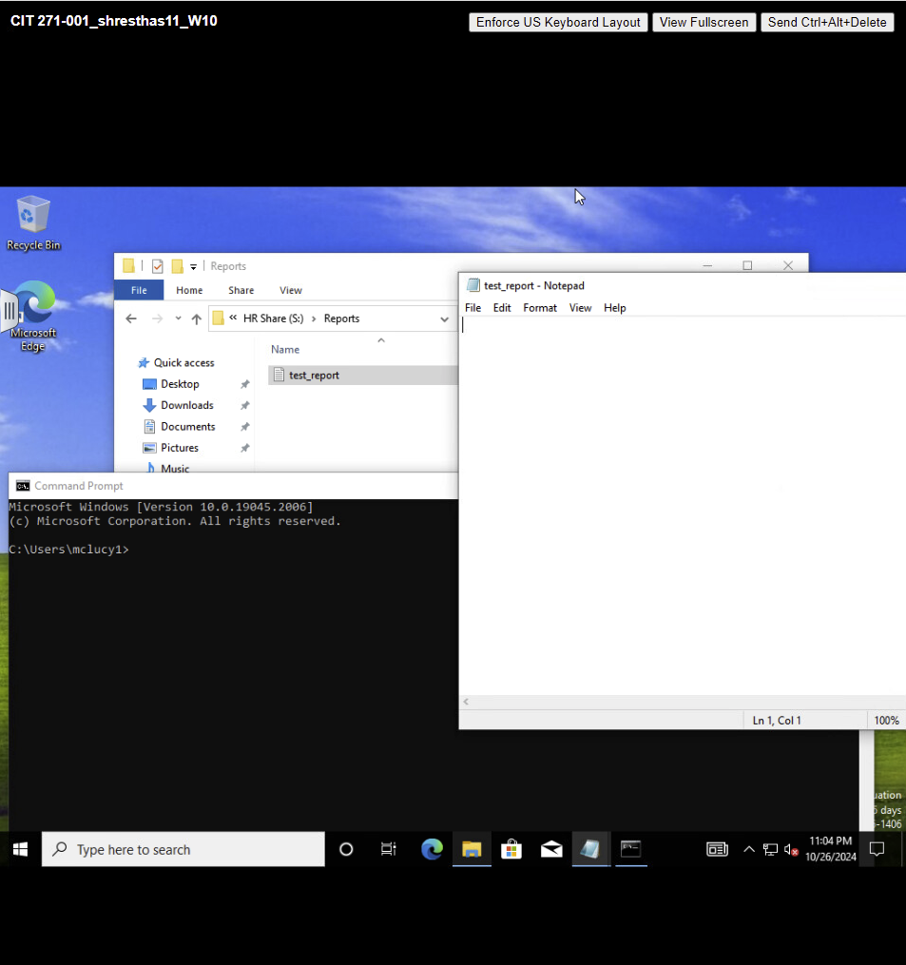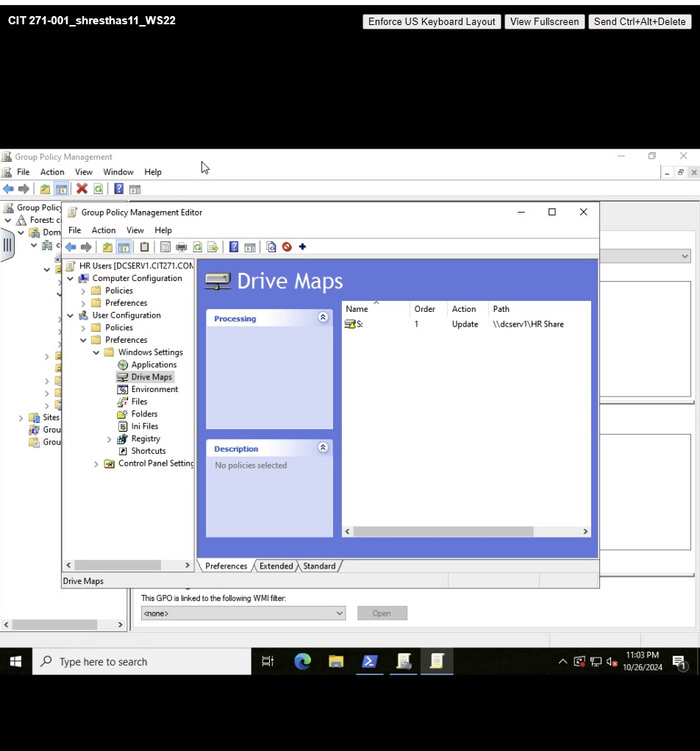

Part 3:

# Define variables
$share_path = "C:\File_Shares\Sales_Share"
$share_name = "Sales Share"
$share_group = "Sales Users"
$campaigns_folder = "$share_path\Campaigns"
$campaigns_group = "Sales Campaigns Users"
$campaigns_user = "mcdaisy1"
$quota_path = $share_path
$test_file = "$campaigns_folder\test_campaign.txt"

# Step 1: Create the Sales_Share folder if it doesn't exist
if (!(Test-Path -Path $share_path)) {
New-Item -Path $share_path -Type Directory
}

# Step 2: Set permissions for Sales Users group
$acl = Get-ACL $share_path
$access_rule = New-Object System.Security.AccessControl.FileSystemAccessRule("$share_group", "ReadAndExecute", "ContainerInherit,ObjectInherit", "None", "Allow")
$acl.AddAccessRule($access_rule)
Set-ACL -Path $share_path -AclObject $acl

# Step 3: Share the folder with full access for Sales Users
New-SmbShare -Name $share_name -Path $share_path -FullAccess $share_group

# Step 4: Create the Campaigns subfolder if it doesn't exist
if (!(Test-Path -Path $campaigns_folder)) {
New-Item -Path $campaigns_folder -Type Directory
}

# Step 5: Create Sales Campaigns Users group
New-ADGroup -Name $campaigns_group -SamAccountName $campaigns_group -GroupCategory Security -GroupScope Global -DisplayName $campaigns_group -Path "OU=Groups,DC=cit271,DC=com"

# Step 6: Add mcdaisy1 to the Sales Campaigns Users group
Add-ADGroupMember -Identity $campaigns_group -Members $campaigns_user

# Step 7: Grant Modify permissions to Sales Campaigns Users for the Campaigns folder
$campaigns_acl = Get-ACL $campaigns_folder
$campaigns_rule = New-Object System.Security.AccessControl.FileSystemAccessRule($campaigns_group, "Modify", "ContainerInherit,ObjectInherit", "None", "Allow")
$campaigns_acl.AddAccessRule($campaigns_rule)
Set-ACL -Path $campaigns_folder -AclObject $campaigns_acl

# Step 8: Create a blank text file in the Campaigns folder
New-Item -Path $test_file -ItemType File

# Step 9: Set a 2GB quota for the Sales_Share folder
New-FsrmQuota -Path $quota_path -Size 2GB

